Springboard Data Science Career Track

Capstone Project

‘Right Place Right Time’

PASSNYC: Data Science for Good Challenge

Manju Nair (2019)

Contents

Introduction 3

Overview of Data Set 4

Data Wrangling 4

Exploratory Data Analysis 5

1. SHSAT offer Ratio of Black- Hispanic Population 11

2. SHSAT offer Distribution of White - Asian Population 11

3. SHSAT offer Distribution of ELA 4s Students 12

4. SHSAT offer Distribution of Math 4s Students 13

5. ENI Distribution Feeder and Non–feeder schools 14

6. Black-Hispanic Distribution in Feeder and Non-feeder schools 14

7. Scatterplot of ENI and Bl- Hi Distribution 15

Machine Learning 16

Approach for Data Modeling 16

Data Modeling 17

Feature Importance 17

Results and Recommendations 18

Training Required or not List 18

School list with option to display Training on OpenStreetMap 19

Awareness Sessions required List 19

School list with option to display Training on OpenStreetMap 20

Future Work 20

# Introduction

To gain entry to New York City’s eight ultracompetitive specialized public high schools (SPHS), eighth graders must take a common entrance exam (SHSAT). Out of about 600 public middle schools, just 10 schools account for more than 25 percent of the seats filled in, according to Education Department data. Though the larger body of NYC’s school system is two-thirds Hispanic and Black, it is interesting to note that these 10 middle schools are disproportionately Asian and White. Also worth noting is the fact that at the top 10 schools, 70% of students take SHSAT**, whereas on an average in any other middle school in NYC, 35% of students take SHSAT**. There has been demands from all walks of society to build pressure on the city’s governing council to take steps to increase the diversity of students gaining admission to these high schools.

PASSNYC is a not for profit organization that aims to increase the diversity of students taking and qualifying in SHSAT. With its `Data Science for Good Challenge’ ,PASSNYC aims to use the power of data science to increase the effectiveness of its current **‘Outreach’** program, which identifies suitable schools and coaches its eligible students from economically and socially backward backgrounds , enabling them to qualify in SHSAT. It also focuses efforts in popularizing ‘SHSAT’ and ‘SPHS’ in schools located in under-performing areas that are historically underrepresented in SHSAT registration.

Right Place Right Time’ project solves this challenge by

1. Analyzing the existing publicly available relevant data sets to observe significant patterns and correlations amongst the various features,
2. Using ensemble methods to find the most important features influencing the selection criteria for candidates in SHSAT the most and
3. Designing a robust machine learning model to successfully predict separate lists of schools requiring training and awareness creation sessions, that PASSNYC can focus on for maximum impact.

# Overview of Data Set

* PASSNYC has shared 2016 School Explorer data which has all the demographic and other relevant data about the NYC schools, contained in 1272 Rows and x 161columns
* 2013_-_2018_Demographic_Snapshot_School which give demographic details from the past 5 years
* SHSAT_Admissions_Test_Offers_By_Sending_School for three academic years that contains details like number of test takers, no of offers received and number of students in class for each of the schools

# Data Wrangling

In order to aid PASSNYC, the data sets have to be explored in detail to check whether any trends or patterns can be observed that would help identify the schools that need help

1. Cleaning and Consolidating the Data

In order to consolidate PASSNYC data from different years (and different file formats), column headers were standardized. Some unnecessary attributes were dropped to reduce dimensionality. A couple of new columns were introduced, to calculate scores based on values of some feature variables, which would eventually become the labels for the Machine Learning Algorithm. For some columns, the value was categorization with words like ‘Meeting Target’, Approaching Target, and ‘Exceeded Target’. That was converted to numeric ranking ‘1’,’2’,’3’.

1. Missing Values

Some columns in the dataset had missing values and there were a few inconsistencies in notation that were adjusted for ease of future analysis. Dropna and fillna were used to drop if the number of rows were insignificant to the data and to replace using mean value as applicable for each of the specific case.

1. Outliers

There were not much significant outliers to be worked upon

# Exploratory Data Analysis

'School Explorer' data frame has a huge set of feature variables and doing a thorough EDA is key to finding out , which of this have the maximum impact on the middle school's getting their students admitted to the Specialized High Schools(SPHS). The task is in finding out which feature variables are key in helping shift focus to the right set of schools.

It makes sense to plot a scatter plot between the SHSAT offer ratio against some of the feature variables over the three years to see if there is any co-relation

Given below are some of the scatter plots that I generated. (Please refer the ipynb file for EDA for a comprehensive set)

## SHSAT offer Ratio of Black- Hispanic Population

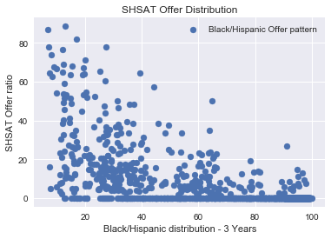

1. SHSAT offer Distribution of White - Asian Population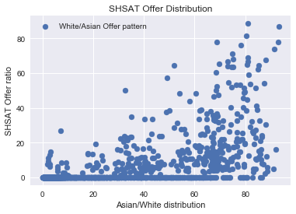

* The Offer ratio plotted against both the population sets also have a correlation coefficient of around 60% only.
* However it is interesting to note that the offer ratio goes up as the White- Asian population in schools go up, whereas, for the Black Hispanic population, with the increase in population, the offer rate was coming down

## SHSAT offer Distribution of ELA 4s Students

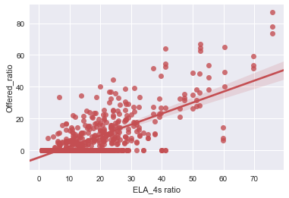

## SHSAT offer Distribution of Math 4s Students

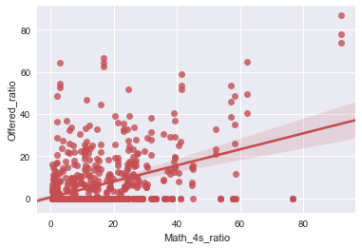

* The Offer ratio plotted against both the ELA 4s scores and Math 4s scores of all the middle schools
* It can be noted from the scatterplot, the ELA 4s and Math 4s scores show a somewhat substantial correlation with the Offers received from SPHS.

Schools are categorized into Feeder Schools (schools that have students who qualify the SHSAT exams) and Non Feeder Schools (school where students do not qualify in the test) and plot density graphs with a couple of feature demographics, to see if there is any correlation.

## ENI Distribution Feeder and Non–feeder schools

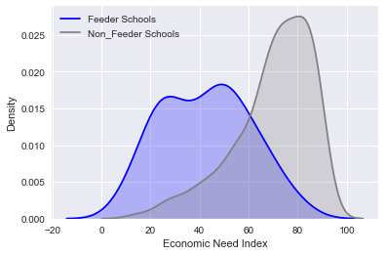

## Black-Hispanic Distribution in Feeder and Non-feeder schools

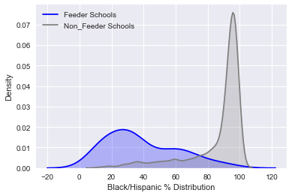

## Scatterplot of ENI and Bl- Hi Distribution

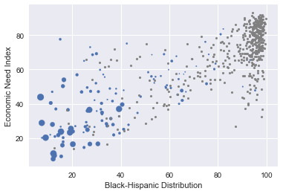

It can be seen that

* Feeder and non-feeder schools are strikingly different in terms of their racial composition and economic need level
* The scatterplot above visualizes the positive correlation (r = 0.78) between ENI and % Black and Hispanic students.
* Feeder schools (larger-sized blue points) tend to have low-to-medium ENI and lower proportion of Black or Hispanic students, while non-feeder schools (gray points) cluster around the upper right corner of the plot

# Machine Learning

## Approach for Data Modeling

* Main objective of the program is to identify schools
  1. with academically qualified students, which would benefit from training programs. Currently, at least some students in these schools are taking SHSAT but without good results.(list1)
  2. where the awareness of SHSAT is less and there are not many test takers. In such schools PASSNYC can do road shows and immersion programs to popularize the program and its benefits.(list2)

To rank the schools, I calculate two scores for all schools,

,

with a lower score indicating a training requirement for the school.

* Need_Training_Score and Need_Awareness_Score are later classified into ‘0’ or ‘1’ based on score value to make the target variable a classifier. Their classification is done based on the values of a set of feature variables in the data set.

This dataset has close to 50 feature variables and plotting a co-relation for each of these variables would be impractical.

This is where an ensemble method like Random Forest can help.Random Forest is a flexible, easy to use machine learning algorithm that produces, even without hyper-parameter tuning, a great result most of the time. It is very simple to use but at the same time very effective.

## Data Modeling

### Feature Importance

With random forest algorithm, it is very easy to measure the relative importance of each feature on the prediction. It measures feature importance by looking at how much the tree nodes, which use that feature, reduce impurity across all trees in the forest. It computes this score automatically for each feature after training and scales the results, so that the sum of all importance is equal to 1.

From the feature importance score, we can decide which features to drop, and which ones to keep.

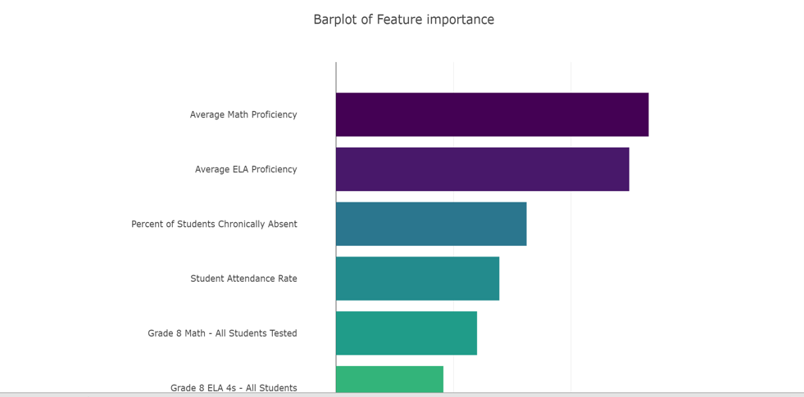

I used Random Forest Classifier which is a very popular algorithm to solve classification problems to solve this problem. I reserve a test data size of 25% and train the model on 75%. It gives a Mean Absolute Error of 0.08 which is very minimal and the cross validation score is 0.9, which ensures a good prediction, as the model ensures a 91% accuracy in prediction in the list of schools requiring training.

For the awareness requirement list, Mean Absolute Error was 0.13 which is very minimal and the cross validation score is again 0.91, which ensures a good prediction, as the model ensures a 91% accuracy in prediction.

# Results and Recommendations

Using this prediction model, we can predict whether any public middle school in NYC would make it to the list of PASSNYC's training_required or awareness_required lists, if we have schools' students' performance data and other feature data.

Below, I have taken a new data set (schools_testdata_df) that has not been used in training, for prediction.

## Training required or not list

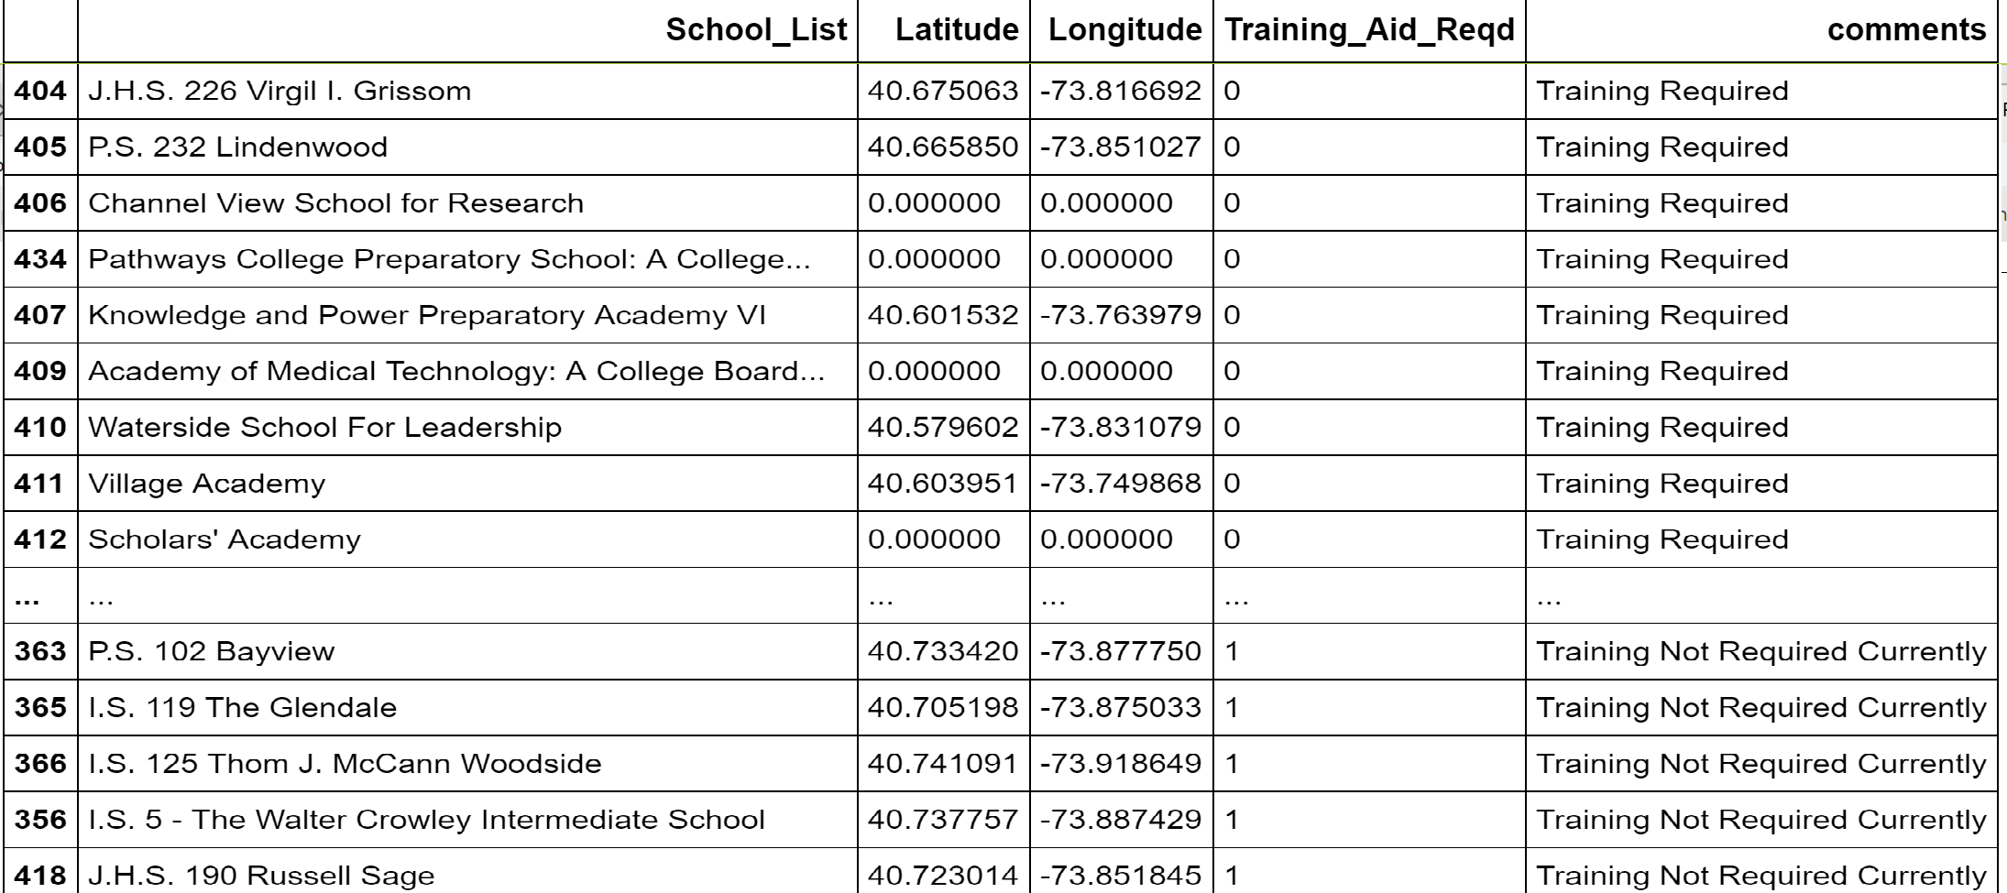

School list with option to display option on OpenStreetMap

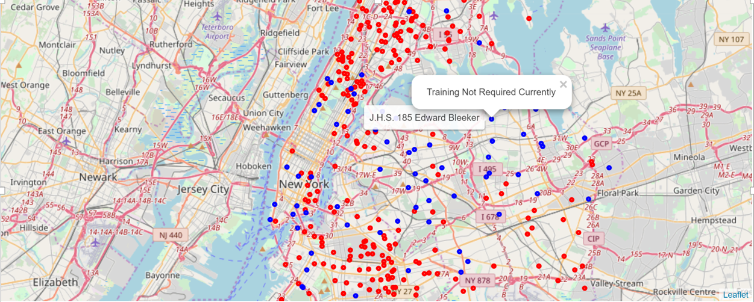

## Awareness sessions required or not list

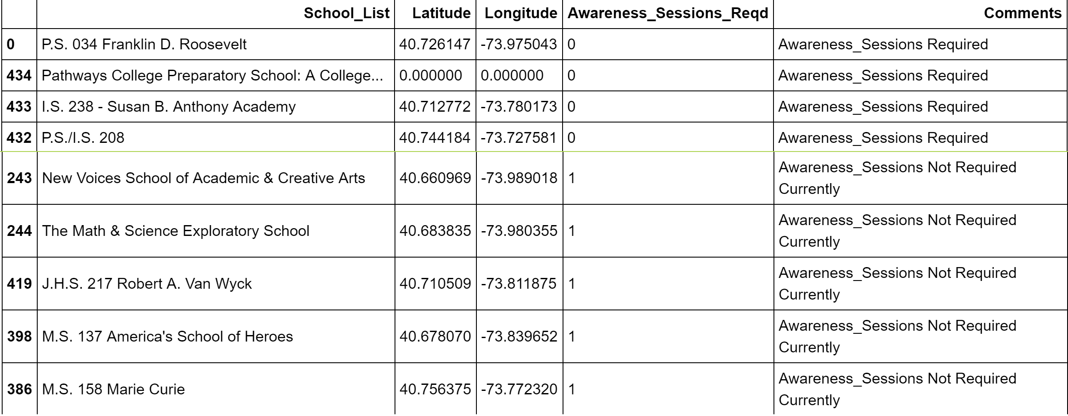

## School list with option to display option on OpenStreetMap

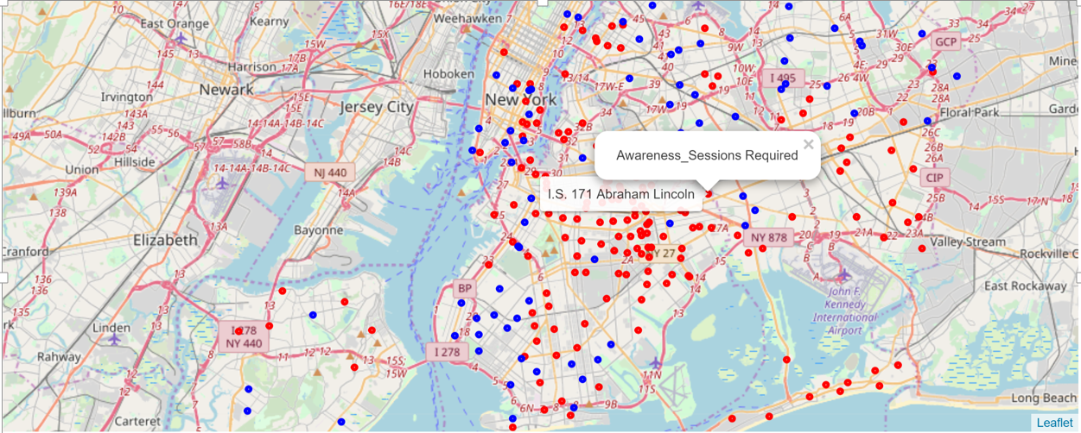

# 

# Future Work

The list of schools can be further categorized, based on

* + geography/ Burroughs of NYC
  + based on the average school income
  + ELA and math scores and ranking given or grouped up ,

so that training plans can be tailored according to the needs of each of these groups.

# APPENDIX

## List of feature variables:

Economic Need Index float64

School Income Estimate object

Percent ELL object

Percent Asian object

Percent Black object

Percent Hispanic object

Percent Black / Hispanic object

Percent White object

Student Attendance Rate object

Percent of Students Chronically Absent object

Rigorous Instruction % object

Rigorous Instruction Rating object

Collaborative Teachers % object

Collaborative Teachers Rating object

Supportive Environment % object

Supportive Environment Rating object

Effective School Leadership % object

Effective School Leadership Rating object

Strong Family-Community Ties % object

Strong Family-Community Ties Rating object

Trust % object

Trust Rating object

Student Achievement Rating object

Average ELA Proficiency float64

Average Math Proficiency float64

Grade 3 ELA - All Students Tested int64

Grade 3 ELA 4s - All Students int64

Grade 3 ELA 4s - American Indian or Alaska Native int64

Grade 3 ELA 4s - Black or African American int64

Grade 3 ELA 4s - Hispanic or Latino int64

Grade 3 ELA 4s - Asian or Pacific Islander int64

Grade 3 ELA 4s - White int64

Grade 3 ELA 4s - Multiracial int64

Grade 3 ELA 4s - Limited English Proficient int64

Grade 3 ELA 4s - Economically Disadvantaged int64

Grade 3 Math - All Students tested int64

Grade 3 Math 4s - All Students int64

Grade 3 Math 4s - American Indian or Alaska Native int64

Grade 3 Math 4s - Black or African American int64

Grade 3 Math 4s - Hispanic or Latino int64

Grade 3 Math 4s - Asian or Pacific Islander int64

Grade 3 Math 4s - White int64

Grade 3 Math 4s - Multiracial int64

Grade 3 Math 4s - Limited English Proficient int64

Grade 3 Math 4s - Economically Disadvantaged int64

Grade 4 ELA - All Students Tested int64

Grade 4 ELA 4s - All Students int64

Grade 4 ELA 4s - American Indian or Alaska Native int64

Grade 4 ELA 4s - Black or African American int64

Grade 4 ELA 4s - Hispanic or Latino int64

Grade 4 ELA 4s - Asian or Pacific Islander int64

Grade 4 ELA 4s - White int64

Grade 4 ELA 4s - Multiracial int64

Grade 4 ELA 4s - Limited English Proficient int64

Grade 4 ELA 4s - Economically Disadvantaged int64

Grade 4 Math - All Students Tested int64

Grade 4 Math 4s - All Students int64

Grade 4 Math 4s - American Indian or Alaska Native int64

Grade 4 Math 4s - Black or African American int64

int64

Grade 4 Math 4s - Asian or Pacific Islander int64

Grade 4 Math 4s - White int64

Grade 4 Math 4s - Multiracial int64

Grade 4 Math 4s - Limited English Proficient int64

Grade 4 Math 4s - Economically Disadvantaged int64

Grade 5 ELA - All Students Tested int64

Grade 5 ELA 4s - All Students int64

Grade 5 ELA 4s - American Indian or Alaska Native int64

Grade 5 ELA 4s - Black or African American int64

Grade 5 ELA 4s - Hispanic or Latino int64

Grade 5 ELA 4s - Asian or Pacific Islander int64

Grade 5 ELA 4s - White int64

Grade 5 ELA 4s - Multiracial int64

Grade 5 ELA 4s - Limited English Proficient int64

Grade 5 ELA 4s - Economically Disadvantaged int64

Grade 5 Math - All Students Tested int64

Grade 5 Math 4s - All Students int64

Grade 5 Math 4s - American Indian or Alaska Native int64

Grade 5 Math 4s - Black or African American int64

Grade 5 Math 4s - Hispanic or Latino int64

Grade 5 Math 4s - Asian or Pacific Islander int64

Grade 5 Math 4s - White int64

Grade 5 Math 4s - Multiracial int64

Grade 5 Math 4s - Limited English Proficient int64

Grade 5 Math 4s - Economically Disadvantaged int64

Grade 6 ELA - All Students Tested int64

Grade 6 ELA 4s - All Students int64

Grade 6 ELA 4s - American Indian or Alaska Native int64

Grade 6 ELA 4s - Black or African American int64

Grade 6 ELA 4s - Hispanic or Latino int64

Grade 6 ELA 4s - Asian or Pacific Islander int64

Grade 6 ELA 4s - White int64

Grade 6 ELA 4s - Multiracial int64

Grade 6 ELA 4s - Limited English Proficient int64

Grade 6 ELA 4s - Economically Disadvantaged int64

Grade 6 Math - All Students Tested int64

Grade 6 Math 4s - All Students int64

Grade 6 Math 4s - American Indian or Alaska Native int64

Grade 6 Math 4s - Black or African American int64

Grade 6 Math 4s - Hispanic or Latino int64

Grade 6 Math 4s - Asian or Pacific Islander int64

Grade 6 Math 4s - White int64

Grade 6 Math 4s - Multiracial int64

Grade 6 Math 4s - Limited English Proficient int64

Grade 6 Math 4s - Economically Disadvantaged int64

Grade 7 ELA - All Students Tested int64

Grade 7 ELA 4s - All Students int64

Grade 7 ELA 4s - American Indian or Alaska Native int64

Grade 7 ELA 4s - Black or African American int64

Grade 7 ELA 4s - Hispanic or Latino int64

Grade 7 ELA 4s - Asian or Pacific Islander int64

Grade 7 ELA 4s - White int64

Grade 7 ELA 4s - Multiracial int64

Grade 7 ELA 4s - Limited English Proficient int64

Grade 7 ELA 4s - Economically Disadvantaged int64

Grade 7 Math - All Students Tested int64

Grade 7 Math 4s - All Students int64

Grade 7 Math 4s - American Indian or Alaska Native int64

Grade 7 Math 4s - Black or African American int64

Grade 7 Math 4s - Hispanic or Latino int64

Grade 7 Math 4s - Asian or Pacific Islander int64

Grade 7 Math 4s - White int64

Grade 7 Math 4s - Multiracial int64

Grade 7 Math 4s - Limited English Proficient int64

Grade 7 Math 4s - Economically Disadvantaged int64

Grade 8 ELA - All Students Tested int64

Grade 8 ELA 4s - All Students int64

Grade 8 ELA 4s - American Indian or Alaska Native int64

Grade 8 ELA 4s - Black or African American int64

Grade 8 ELA 4s - Hispanic or Latino int64

Grade 8 ELA 4s - Asian or Pacific Islander int64

Grade 8 ELA 4s - White int64

Grade 8 ELA 4s – Multiracial int64

Grade 8 ELA 4s - Limited English Proficient int64

Grade 8 ELA 4s - Economically Disadvantaged int64

Grade 8 Math - All Students Tested int64

Grade 8 Math 4s - All Students int64

Grade 8 Math 4s - American Indian or Alaska Native int64

Grade 8 Math 4s - Black or African American int64

Grade 8 Math 4s - Hispanic or Latino int64

Grade 8 Math 4s - Asian or Pacific Islander int64

Grade 8 Math 4s - White int64

Grade 8 Math 4s - Multiracial int64

Grade 8 Math 4s - Limited English Proficient int64

Grade 8 Math 4s - Economically Disadvantaged int64